* Bubble Sort Program Source Code:

//Program for Bubble Sorting

#include<stdio.h>

void main()

{int i,j,n;

printf("enter the size of array:");

scanf("%d",&n);

int a[n],c;

printf("enter the values in array:");

for(i=0;i<n;i++)

scanf("%d",&a[i]);

{for(i=1;i<n;i++)

{for(j=0;j<n-i;j++)

if(a[j]>a[j+1])

{

c=a[j];

a[j]=a[j+1];

a[j+1]=c;

}}}

printf("Output:");

printf("\n");

for(i=0;i<n;i++)

{printf("%d\n",a[i]);}

//By Gaurav Yadav(11911038|CSE)

}

* Bubble Sort Program Output:

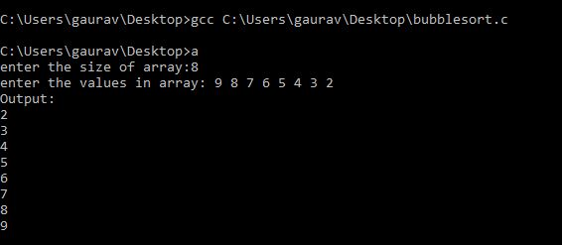

* Selection Sort Program Source Code:

//Selection Sort Program

#include <stdio.h>

void main()

{

int n,flag, t;

printf("Enter the size of array:");

scanf("%d", &n);

int a[n];

for (int i = 0; i < n; i++)

scanf("%d", &a[i]);

for (int i = 0; i< (n - 1); i++)

{

flag = i;

for (int j = i+ 1; j < n; j++)

{

if (a[flag] > a[j])

{flag= j;}

}

if (flag != i)

{

t = a[i];

a[i] = a[flag];

a[flag] = t;

}

}

printf("Output:");

printf("\n");

for (int i = 0; i < n; i++)

{printf("%d\n", a[i]);}

//By Gaurav Yadav(11911038|CSE)

}

* Selection Sort Program Output:

